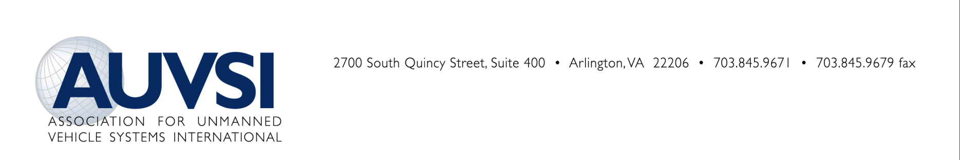

AUVSI PRIVACY RIGHTS STATEMENT

AUVSI Statement on U.S. Constitutional Privacy Rights

The Association for Unmanned Vehicle Systems International (AUVSI) supports the expanded use of unmanned systems, and believes unmanned systems can be used lawfully and responsibly without infringing upon Constitutional rights. AUVSI encourages an open dialogue at the national, state and local level with all parties, including law enforcement, citizens and advocacy groups, to address concerns about the use of unmanned systems.

Summary

Unmanned systems, in particular, unmanned aircraft systems (UAS), are tools to do tasks that are too difficult, dangerous, dull, or expensive for manned aviation. An unmanned aircraft is simply a vehicle designed to carry some sort of system payload, such as a camera.

Although the use of the system payload onboard an unmanned aircraft defines its purpose, differentiating it from hobby or model aircraft, the use of these system payloads is not new. In fact, manned aircraft have been using cameras and sensors for decades.

AUVSI believes there is already a robust legal framework to allow aircraft systems to operate without infringing upon Constitutional rights protecting privacy, and that this framework is applicable and sufficient to guide the use of systems in which the “cockpit” and pilot are on the ground. As with any new technology, there exists the possibility of abuse (for example, computers, the Internet, cellular phones, global positioning systems, satellites, etc.); however, used properly, in accordance with established rules and precedent, unmanned systems have the potential to greatly enhance public safety while allowing for an entirely new industry to be formed.

Public Safety Use

Air support is an invaluable tool for public safety agencies, and the increased use of public UAS will undoubtedly save lives.

The objective of public safety UAS technology is to give an incident commander (whether it be police, fire, search and rescue, or disaster response) access to real time aerial imagery and other pertinent data necessary to efficiently and effectively bring an event to a successful conclusion. The end result is increased public safety.

The relatively small size and low cost of UAS will allow most, if not all, local public safety departments the ability to access aerial imagery. Law enforcement and first responders are likely to initially use small UAS (weighing less than 55 lbs) to give them situational awareness. These systems are very different than military systems, which many people picture when they think of an unmanned aircraft.

Small UAS have short flight duration; therefore, they will likely be used to respond to a specific incident (flown on-demand). These systems will not be serving as a patrol vehicle, and due to their size, speed, and range, they are not practical for following suspects or enforcing traffic violations. In addition, due to size and weight restrictions, the sensors (cameras) on these small platforms are considerably less capable than the sensors currently being used on larger, manned aircraft.

Some of the potential uses of UAS in firefighting include: aerial surveillance, mapping, chemical sniffing, hot spot detection, designating water or suppressant drop areas, providing communication relays, search and rescue, medical evacuation, resupply, and weather monitoring. For law enforcement, UAS uses include aerial surveillance, suspect tracking, crash/crime scene photography, incident scene management, threat assessment of inaccessible areas, and emergency broadcast messaging.

Situational awareness is crucial for first responders and public safety agencies. Frequently, the most effective method to gather this information is from above. The development and use of UAS has the potential to increase public safety by allowing most, if not all, public safety agencies to acquire an airborne asset.

Existing Legal Framework

The Fourth Amendment of the U.S. Constitution prohibits unreasonable searches and seizures and requires search warrants to be based upon probable cause. The U.S. Supreme Court has interpreted the law and issued rulings that restrict the actions of police and their use of technology of all types. Courts, including the U.S. Supreme Court, have repeatedly held that airborne technology cannot be used to invade Constitutionally protected areas.

So far, in determining what a constitutionally protected area is, the U.S. Supreme Court has distinguished between four types of areas: businesses, open fields, curtilage, which is the outside area immediately surrounding a residence, and homes. The Court has held that the expectation of privacy outside a home or outside a business is less than that for inside a residence. AUVSI fully supports law enforcement’s need to get a search warrant if obtaining information from a Constitutionally protected area.

###
The Association for Unmanned Vehicle Systems International (AUVSI) - the world's largest non-profit organization dedicated to the advancement of unmanned systems – represents more than 7,000 members from 55 allied countries and 2,100 organizations involved in the fields of government, industry and academia.
For more information, contact Senior Communications Manager Melanie Hinton, +1 571 255 7786, mhinton@auvsi.org

